STUDENT PORTAL:
PS E:\AI tutor\class_9> tree
Folder PATH listing for volume New Volume
Volume serial number is 000000A1 6A61:D9A7
E:.
├───english
├───maths
├───maths mock tests
├───science
└───science mock tests

Briefly ill explain how the content is present in each folder
Folders english, maths and science have pdf’s with the following nomenclature
Eg : chapter-1-Noun —---- Like this

This is the present website
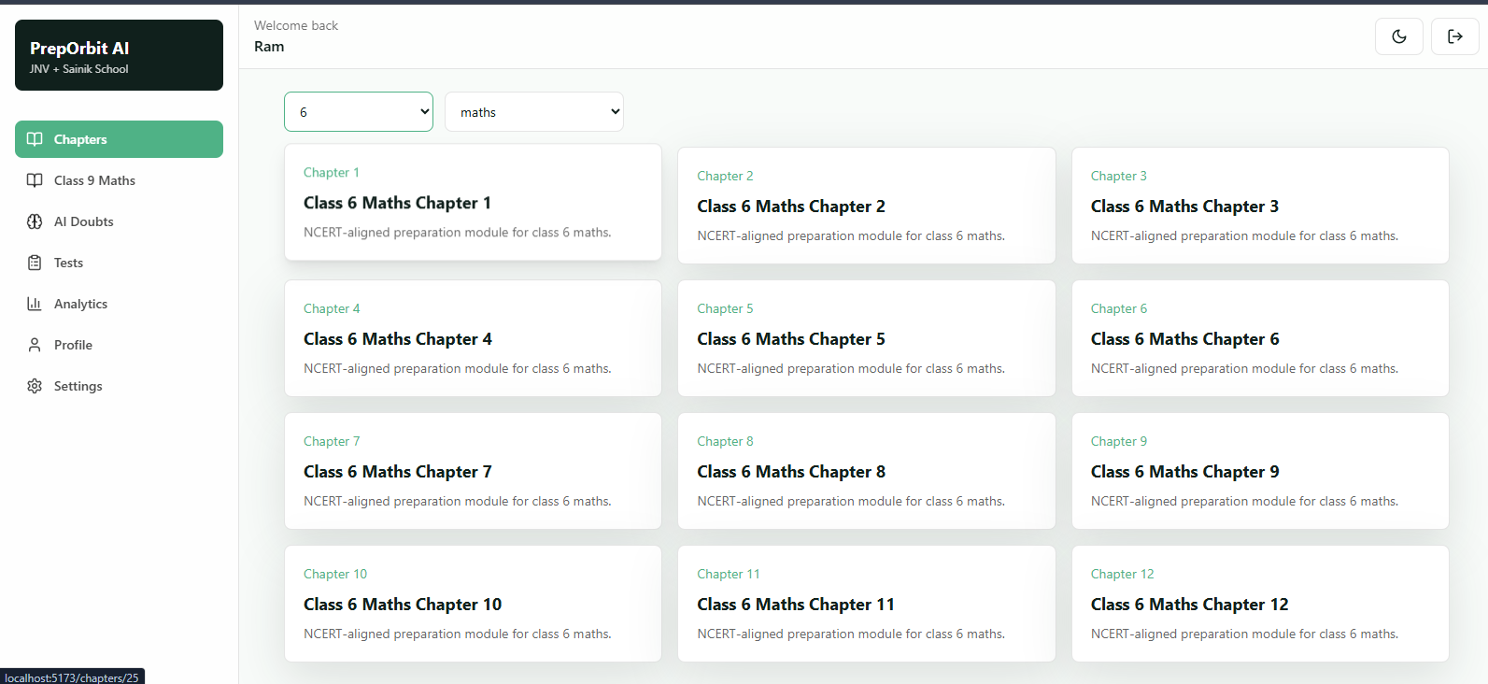
I want it to look like this (red box highlighted must be disabled it must be deleted completely)
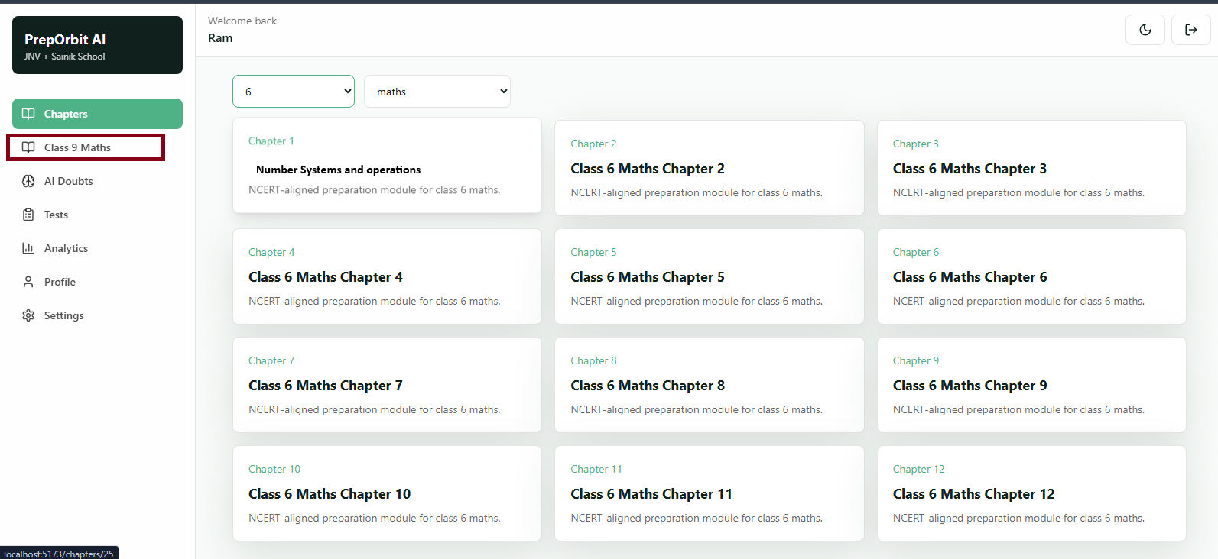
Basically i want the pdf name as module name the pdf name contains two parts chapter number and chapter name so i want to display the chapter number with small text and name highlighted then if user clicks on that chapter name(i mean that box) the corresponding file(pdf) must be opened in the same tab
AI DOUBTS:
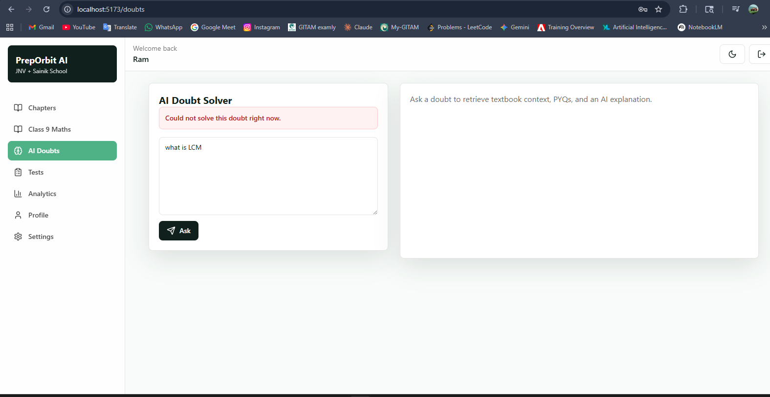
This section isnt working completely idk why here are the logs
Failed to send telemetry event ClientStartEvent: capture() takes 1 positional argument but 3 were given
Failed to send telemetry event ClientCreateCollectionEvent: capture() takes 1 positional argument but 3 were given
INFO: 127.0.0.1:56581 - "POST /api/learning/doubts HTTP/1.1" 500 Internal Server Error
ERROR: Exception in ASGI application
Traceback (most recent call last):
File "C:\Users\Ram.K\AppData\Local\Programs\Python\Python313\Lib\site-packages\chromadb\api\models\CollectionCommon.py", line 90, in wrapper
return func(self, *args, **kwargs)
File "C:\Users\Ram.K\AppData\Local\Programs\Python\Python313\Lib\site-packages\chromadb\api\models\CollectionCommon.py", line 294, in _validate_and_prepare_query_request
validate_filter_set(filter_set=filters)
~~~~~~~~~~~~~~~~~~~^^^^^^^^^^^^^^^^^^^^
File "C:\Users\Ram.K\AppData\Local\Programs\Python\Python313\Lib\site-packages\chromadb\api\types.py", line 345, in validate_filter_set
validate_where(filter_set["where"])
~~~~~~~~~~~~~~^^^^^^^^^^^^^^^^^^^^^
File "C:\Users\Ram.K\AppData\Local\Programs\Python\Python313\Lib\site-packages\chromadb\api\types.py", line 604, in validate_where
raise ValueError(f"Expected where to have exactly one operator, got {where}")
ValueError: Expected where to have exactly one operator, got {'grade': 6, 'source_type': 'textbook'}

During handling of the above exception, another exception occurred:

Traceback (most recent call last):
File "C:\Users\Ram.K\AppData\Local\Programs\Python\Python313\Lib\site-packages\uvicorn\protocols\http\httptools_impl.py", line 409, in run_asgi
result = await app( # type: ignore[func-returns-value]
^^^^^^^^^^^^^^^^^^^^^^^^^^^^^^^^^^^^^^^^^^^^^^
self.scope, self.receive, self.send
^^^^^^^^^^^^^^^^^^^^^^^^^^^^^^^^^^^
)
^
File "C:\Users\Ram.K\AppData\Local\Programs\Python\Python313\Lib\site-packages\uvicorn\middleware\proxy_headers.py", line 60, in __call__
return await self.app(scope, receive, send)
^^^^^^^^^^^^^^^^^^^^^^^^^^^^^^^^^^^^
File "C:\Users\Ram.K\AppData\Local\Programs\Python\Python313\Lib\site-packages\fastapi\applications.py", line 1054, in __call__
await super().__call__(scope, receive, send)
File "C:\Users\Ram.K\AppData\Local\Programs\Python\Python313\Lib\site-packages\starlette\applications.py", line 113, in __call__
await self.middleware_stack(scope, receive, send)
File "C:\Users\Ram.K\AppData\Local\Programs\Python\Python313\Lib\site-packages\starlette\middleware\errors.py", line 187, in __call__
raise exc
File "C:\Users\Ram.K\AppData\Local\Programs\Python\Python313\Lib\site-packages\starlette\middleware\errors.py", line 165, in __call__
await self.app(scope, receive, _send)
File "C:\Users\Ram.K\AppData\Local\Programs\Python\Python313\Lib\site-packages\starlette\middleware\cors.py", line 93, in __call__
await self.simple_response(scope, receive, send, request_headers=headers)
File "C:\Users\Ram.K\AppData\Local\Programs\Python\Python313\Lib\site-packages\starlette\middleware\cors.py", line 144, in simple_response
await self.app(scope, receive, send)
File "C:\Users\Ram.K\AppData\Local\Programs\Python\Python313\Lib\site-packages\starlette\middleware\exceptions.py", line 62, in __call__
await wrap_app_handling_exceptions(self.app, conn)(scope, receive, send)
File "C:\Users\Ram.K\AppData\Local\Programs\Python\Python313\Lib\site-packages\starlette\_exception_handler.py", line 53, in wrapped_app
raise exc
File "C:\Users\Ram.K\AppData\Local\Programs\Python\Python313\Lib\site-packages\starlette\_exception_handler.py", line 42, in wrapped_app
await app(scope, receive, sender)
File "C:\Users\Ram.K\AppData\Local\Programs\Python\Python313\Lib\site-packages\starlette\routing.py", line 715, in __call__
await self.middleware_stack(scope, receive, send)
File "C:\Users\Ram.K\AppData\Local\Programs\Python\Python313\Lib\site-packages\starlette\routing.py", line 735, in app
await route.handle(scope, receive, send)
File "C:\Users\Ram.K\AppData\Local\Programs\Python\Python313\Lib\site-packages\starlette\routing.py", line 288, in handle
await self.app(scope, receive, send)
File "C:\Users\Ram.K\AppData\Local\Programs\Python\Python313\Lib\site-packages\starlette\routing.py", line 76, in app
await wrap_app_handling_exceptions(app, request)(scope, receive, send)
File "C:\Users\Ram.K\AppData\Local\Programs\Python\Python313\Lib\site-packages\starlette\_exception_handler.py", line 53, in wrapped_app
raise exc
File "C:\Users\Ram.K\AppData\Local\Programs\Python\Python313\Lib\site-packages\starlette\_exception_handler.py", line 42, in wrapped_app
await app(scope, receive, sender)
File "C:\Users\Ram.K\AppData\Local\Programs\Python\Python313\Lib\site-packages\starlette\routing.py", line 73, in app
response = await f(request)
^^^^^^^^^^^^^^^^
File "C:\Users\Ram.K\AppData\Local\Programs\Python\Python313\Lib\site-packages\fastapi\routing.py", line 301, in app
raw_response = await run_endpoint_function(
^^^^^^^^^^^^^^^^^^^^^^^^^^^^
...<3 lines>...
)
^
File "C:\Users\Ram.K\AppData\Local\Programs\Python\Python313\Lib\site-packages\fastapi\routing.py", line 214, in run_endpoint_function
return await run_in_threadpool(dependant.call, **values)
^^^^^^^^^^^^^^^^^^^^^^^^^^^^^^^^^^^^^^^^^^^^^^^^^
File "C:\Users\Ram.K\AppData\Local\Programs\Python\Python313\Lib\site-packages\starlette\concurrency.py", line 39, in run_in_threadpool
return await anyio.to_thread.run_sync(func, *args)
^^^^^^^^^^^^^^^^^^^^^^^^^^^^^^^^^^^^^^^^^^^
File "C:\Users\Ram.K\AppData\Local\Programs\Python\Python313\Lib\site-packages\anyio\to_thread.py", line 63, in run_sync
return await get_async_backend().run_sync_in_worker_thread(
^^^^^^^^^^^^^^^^^^^^^^^^^^^^^^^^^^^^^^^^^^^^^^^^^^^^
func, args, abandon_on_cancel=abandon_on_cancel, limiter=limiter
^^^^^^^^^^^^^^^^^^^^^^^^^^^^^^^^^^^^^^^^^^^^^^^^^^^^^^^^^^^^^^^^
)
^
File "C:\Users\Ram.K\AppData\Local\Programs\Python\Python313\Lib\site-packages\anyio\_backends\_asyncio.py", line 2502, in run_sync_in_worker_thread
return await future
^^^^^^^^^^^^
File "C:\Users\Ram.K\AppData\Local\Programs\Python\Python313\Lib\site-packages\anyio\_backends\_asyncio.py", line 986, in run
result = context.run(func, *args)
File "E:\AI tutor\backend\app\api\routes\learning.py", line 87, in solve_doubt
return rag_service.answer_doubt(db, user, payload)
~~~~~~~~~~~~~~~~~~~~~~~~^^^^^^^^^^^^^^^^^^^
File "E:\AI tutor\backend\app\services\rag_service.py", line 12, in answer_doubt
textbook = vector_service.search(request.question, {**filters, "source_type": "textbook"}, limit=5)
File "E:\AI tutor\backend\app\services\vector_service.py", line 51, in search
result = collection.query(
query_embeddings=[embedding],
...<2 lines>...
include=["documents", "metadatas", "distances"],
)
File "C:\Users\Ram.K\AppData\Local\Programs\Python\Python313\Lib\site-packages\chromadb\api\models\Collection.py", line 210, in query
query_request = self._validate_and_prepare_query_request(
query_embeddings=query_embeddings,
...<6 lines>...
include=include,
)
File "C:\Users\Ram.K\AppData\Local\Programs\Python\Python313\Lib\site-packages\chromadb\api\models\CollectionCommon.py", line 93, in wrapper
raise type(e)(msg).with_traceback(e.__traceback__)
File "C:\Users\Ram.K\AppData\Local\Programs\Python\Python313\Lib\site-packages\chromadb\api\models\CollectionCommon.py", line 90, in wrapper
return func(self, *args, **kwargs)
File "C:\Users\Ram.K\AppData\Local\Programs\Python\Python313\Lib\site-packages\chromadb\api\models\CollectionCommon.py", line 294, in _validate_and_prepare_query_request
validate_filter_set(filter_set=filters)
~~~~~~~~~~~~~~~~~~~^^^^^^^^^^^^^^^^^^^^
File "C:\Users\Ram.K\AppData\Local\Programs\Python\Python313\Lib\site-packages\chromadb\api\types.py", line 345, in validate_filter_set
validate_where(filter_set["where"])
~~~~~~~~~~~~~~^^^^^^^^^^^^^^^^^^^^^
File "C:\Users\Ram.K\AppData\Local\Programs\Python\Python313\Lib\site-packages\chromadb\api\types.py", line 604, in validate_where
raise ValueError(f"Expected where to have exactly one operator, got {where}")
ValueError: Expected where to have exactly one operator, got {'grade': 6, 'source_type': 'textbook'} in query.
TESTS:
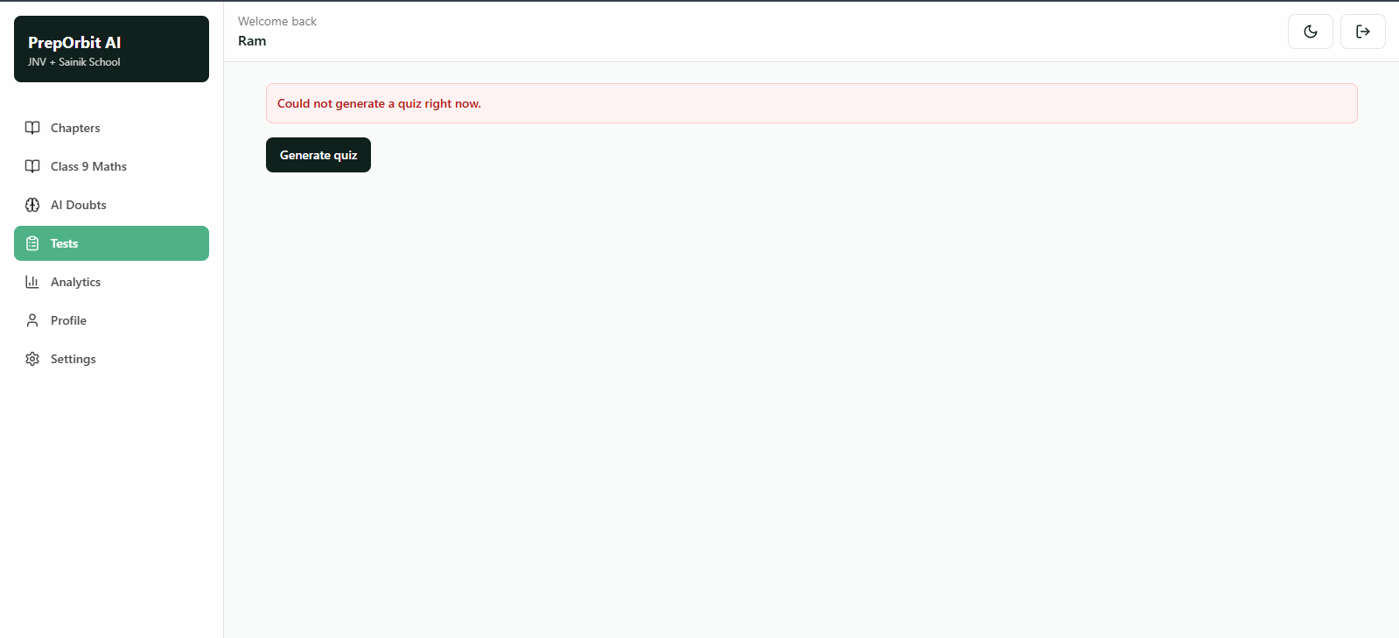
There is no need of generating test using AI in this folder maths mock tests there is a file called questions.json where all the questions with correct answer are present so the engine should use them
The test must be timer based
Two types of tests
1) Test for each module(after completing the module student must attempt that modules quiz then only he/she will be able to proceed for next module)
2) Test on complete subject same timer based and this test’s leaderboard must be displayed(if scores are equal time must be considered)
ANALYTICS:
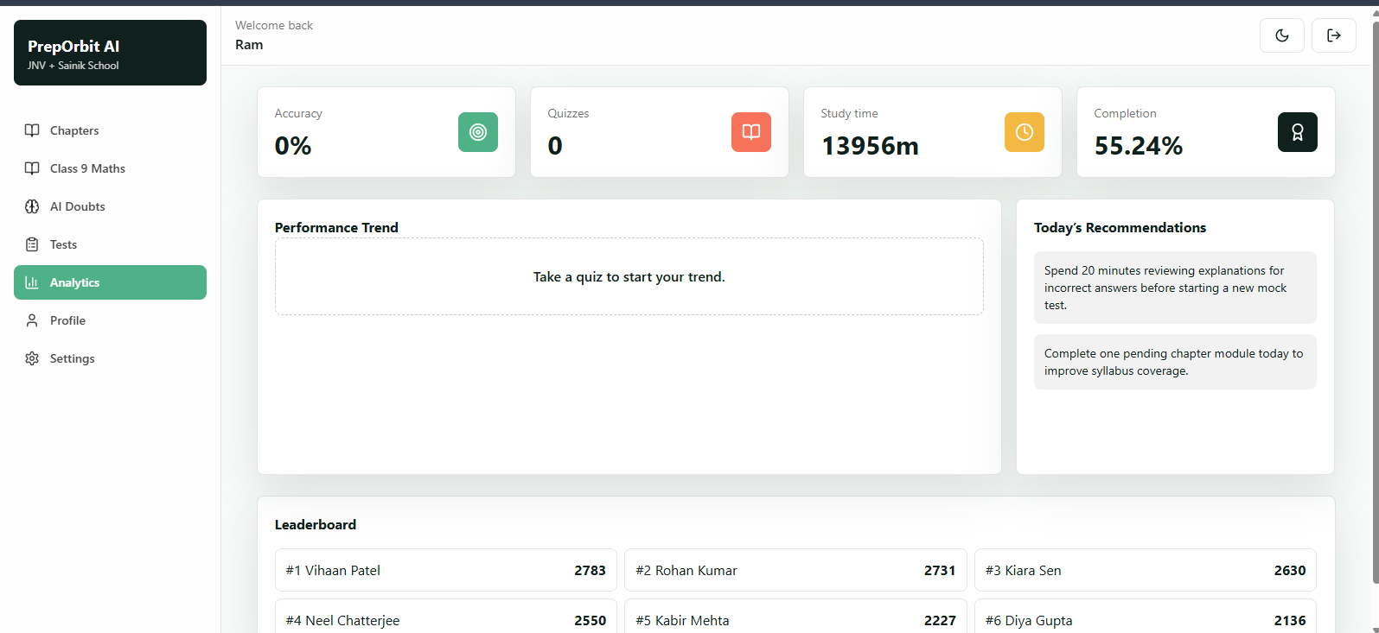
Here everything is static i dont want like every option must contain an engine, must and should show the original analytics for reference use these pictures and features which contain different kinds of analysis dashboards all those must be implemented here
Feature-by-Feature Breakdown

Performance Dashboard
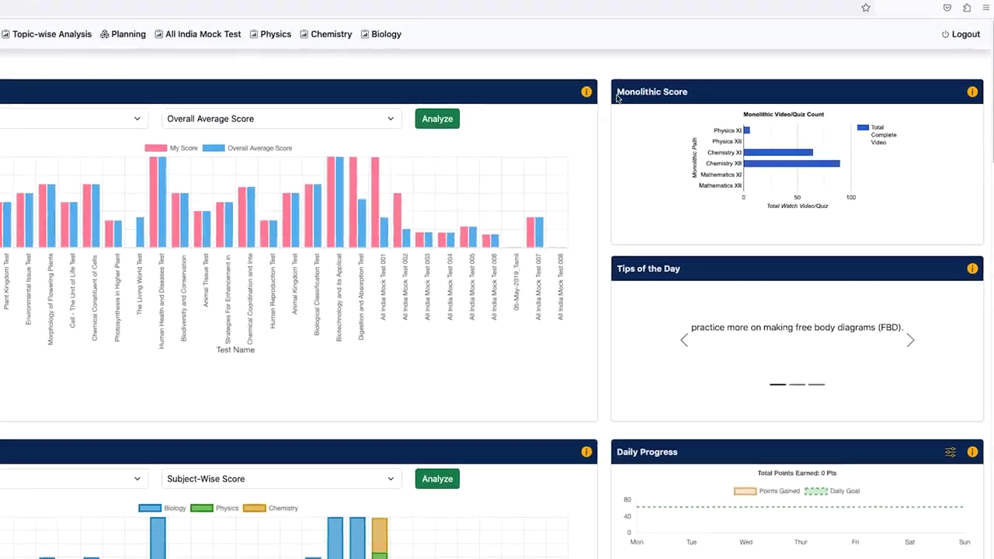 | What it does  - Shows student progress and learning activity  - Displays score movement and performance indicators  - Brings key learning metrics into one view  - Helps students understand preparation status quickly  Can be useful for JNV/Sainik  - JNV/Sainik student dashboard  - Parent progress reporting  - Daily preparation tracking

Weakness and Strength Analysis
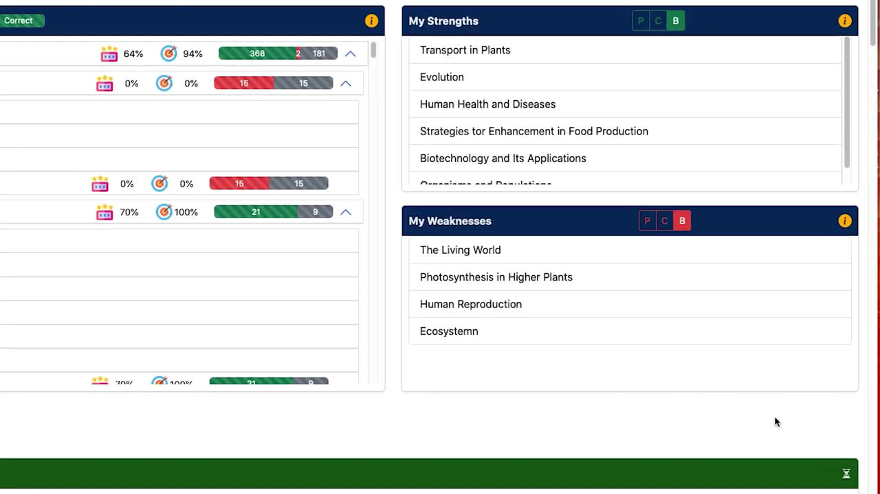 | What it does  - Identifies weak and strong learning areas  - Converts attempt data into improvement signals  - Helps students focus on topics needing attention  - Supports targeted revision instead of random practice  Can be useful for JNV/Sainik  - Weak-area tracking  - Personalized practice sets  - Student improvement reports

Topic-Wise Analysis
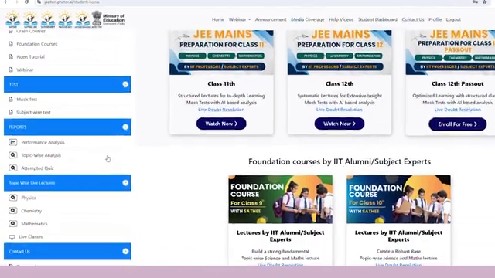 | What it does  - Breaks performance down by topic  - Highlights topic-level score and accuracy  - Supports focused revision planning  - Makes syllabus gaps easier to identify  Can be useful for JNV/Sainik  - Adaptive practice engine  - Smart revision planning  - Chapter/topic mastery tracking

Subject-Wise Mock System
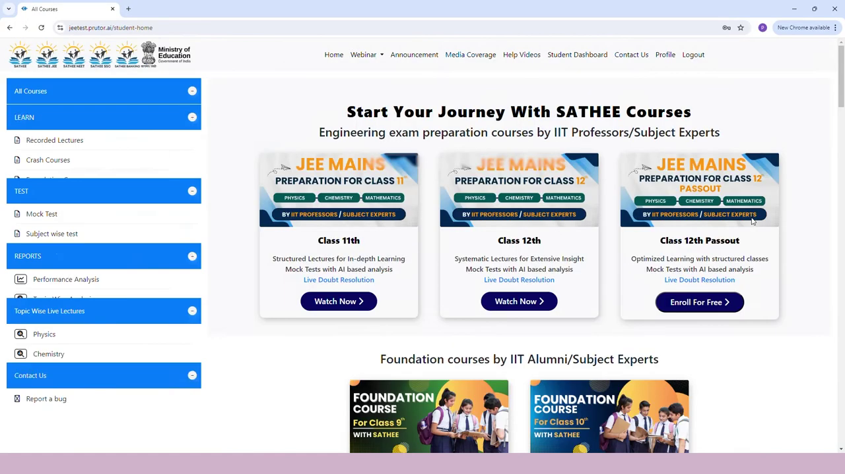 | What it does  - Organizes tests by subject  - Shows subject-level performance differences  - Helps students isolate weak subjects  - Supports sectional preparation  Can be useful for JNV/Sainik  - Math, Reasoning, Language, GK analysis  - Section-wise mock tests  - Subject-specific improvement plans

Guided Learning Mode
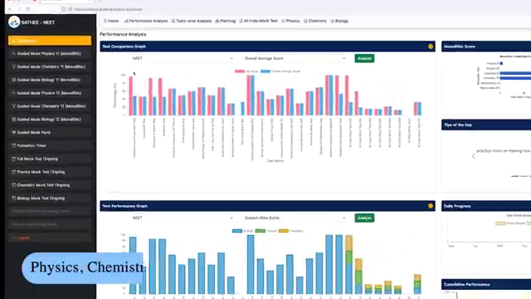 | What it does  - Provides a structured learning flow  - Guides students step by step  - Reduces confusion about what to study next  - Creates a more disciplined study experience  Can be useful for JNV/Sainik  - Younger JNV/Sainik aspirants  - Daily guided preparation path  - Low-supervision self-study model

Mock Test Analysis
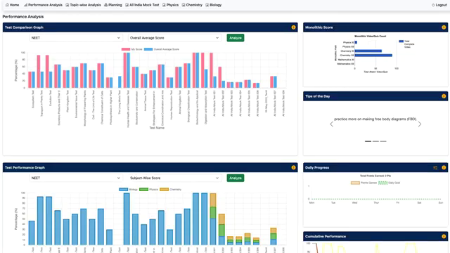 | What it does  - Analyzes performance after mock tests  - Shows score, accuracy, and attempt quality  - Helps students understand mistakes  - Turns mocks into improvement feedback  Can be useful for JNV/Sainik  - JNV/Sainik full mock reports  - Readiness score after each mock  - Mistake-based practice recommendations

Quiz System
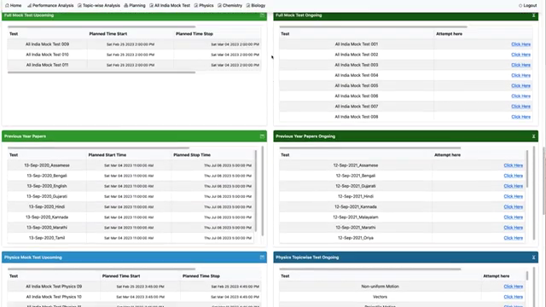 | What it does  - Provides short practice-based assessments  - Allows quick checking of understanding  - Supports repeated low-friction practice  - Can be used for topic or concept revision  Can be useful for JNV/Sainik  - Daily quiz habit  - Concept revision  - Micro-practice before full mocks

Daily Progress Tracking
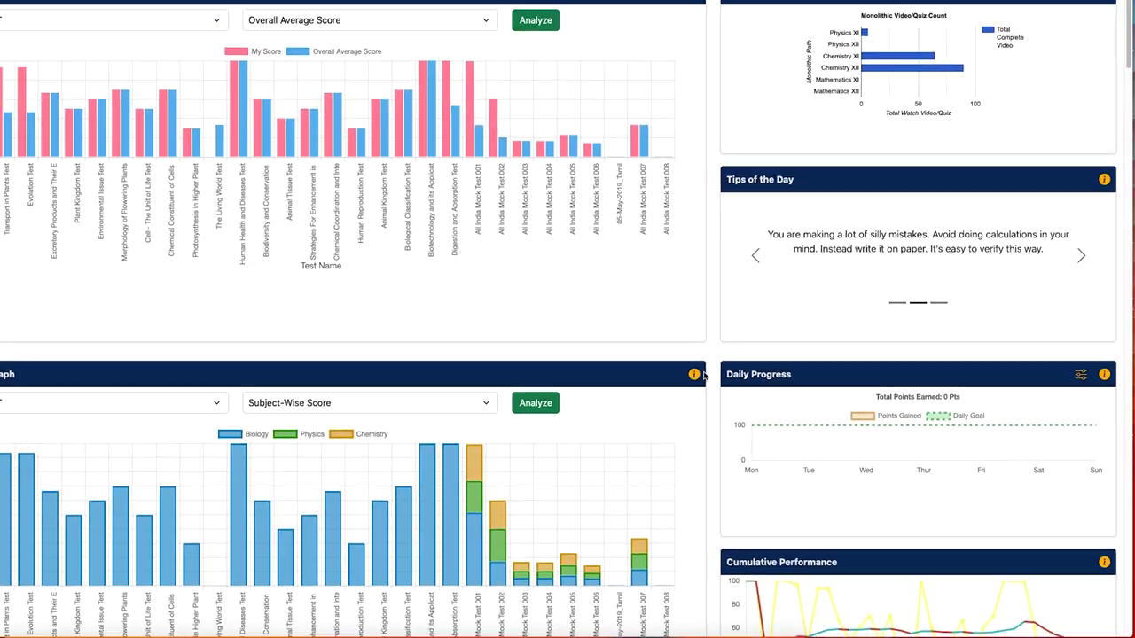 | What it does  - Tracks day-to-day learning activity  - Shows consistency and completed tasks  - Encourages repeat usage  - Makes preparation progress visible  Can be useful for JNV/Sainik  - Student streaks  - Parent-facing weekly reports  - Daily study goals

Personalized Study Planning
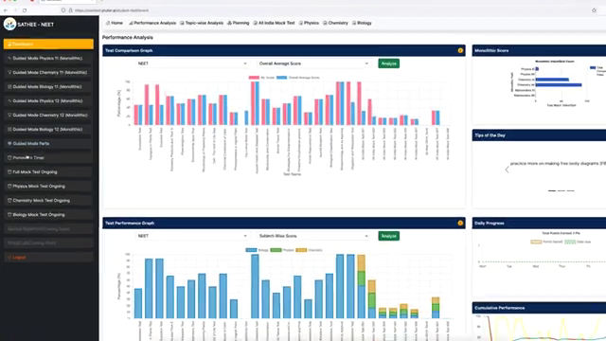 | What it does  - Helps organize study activity  - Supports planned preparation instead of ad hoc practice  - Can connect weak areas with next study tasks  - Improves preparation discipline  Can be useful for JNV/Sainik  - JNV/Sainik study calendar  - Weak-topic based planning  - Exam-date preparation schedule

Performance Comparison
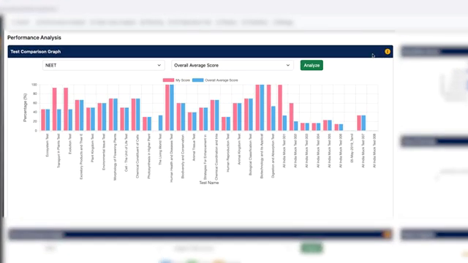 | What it does  - Compares student performance against others  - Creates benchmark awareness  - Helps students understand relative standing  - Can motivate improvement through peer comparison  Can be useful for JNV/Sainik  - Rank band system  - Peer comparison after mocks  - Preparation competitiveness indicator

PARENT PORTAL:
There is nothing i can see in the parent portal while i try to register
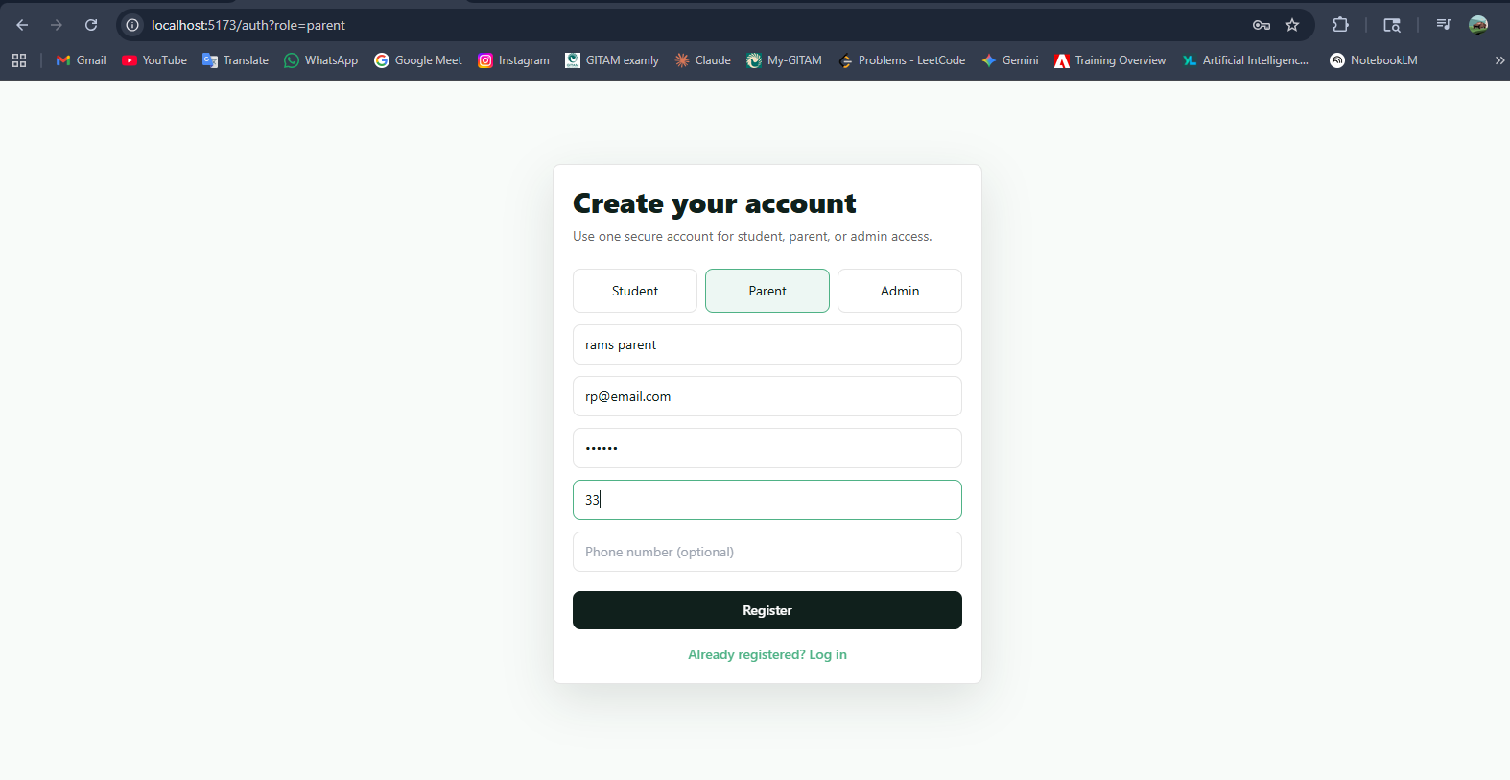
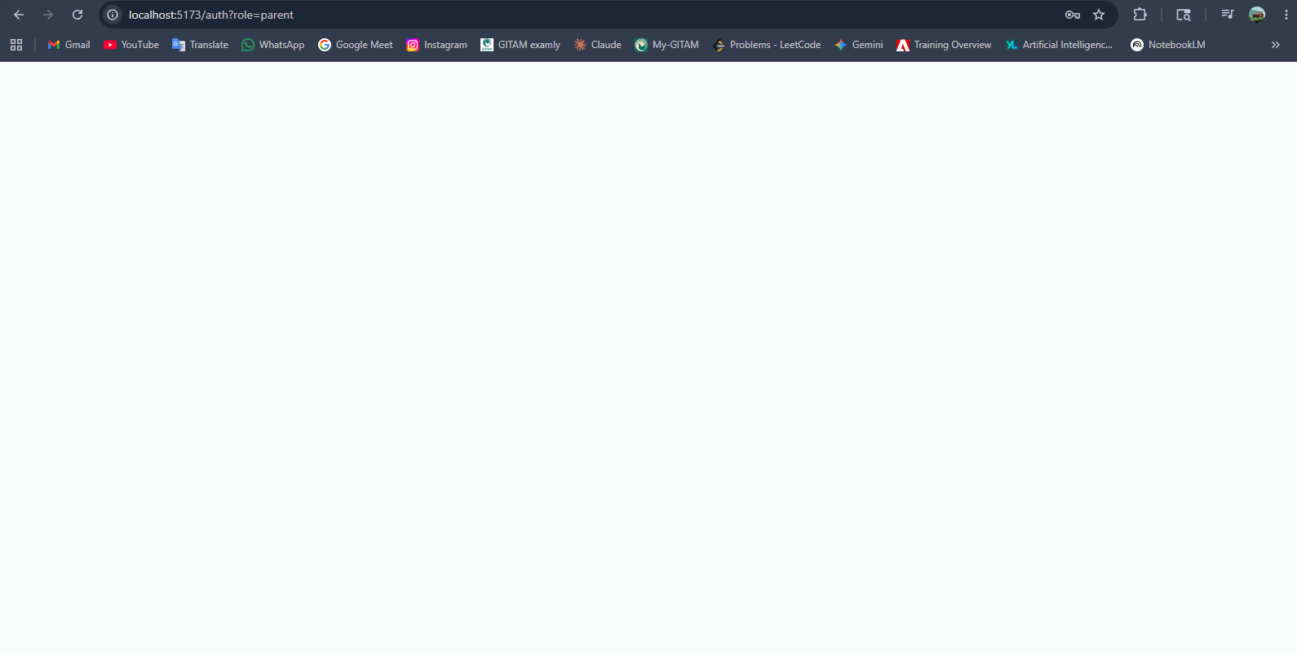
Here are the screenshots observe the logs in the backend
Parent portal must be no leftbar and stuff just the scores, and analytics of their child(how much time they are spending all the dashboards which were placing in the student profile must reflect here too if they are relevant and must be monitored by the parent)
ADMIN PORTAL:
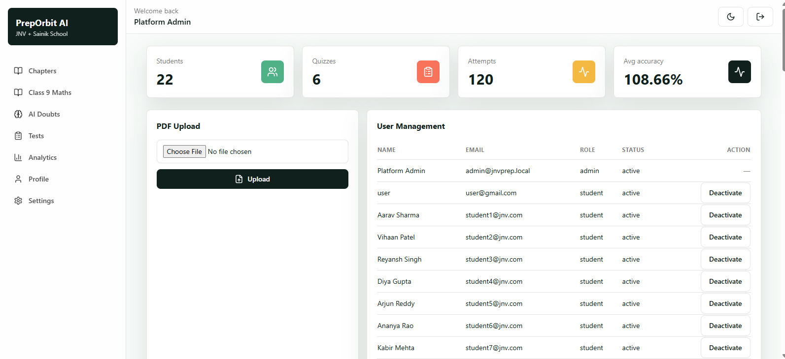
The options Chapters, Class 9 maths these all must be removed those be present only in student portal
The accuracy shows 108% which is unbelievable should fix that
The admin portal must contain the leaderboard in the admin home page
Same like here name, score, percentile like these options and in the left bar in the analytics tab the analytics regarding the students must be present(select accurate parameters to show the analytics)

